Case Understanding
Mr. Ramalingam Venkatesh started the venture in the form of a fast-food restaurant in South Bombay in 1965. Due to the political mis happenings in the country in 1975 and food items were being sold at bare prices. TO overcome the situation Ramalingam Foods introduced Instant Mix in different variants to fulfill the demand of varied customers. The product portfolio included Instant Dosa Mix, Instant Idli Mix, Instant Gulab Jamun Mix, Instant Laddu Mix, instant coffee powder Instant Dhokla mix and other similar products. It allowed the venture to operate at a very low cost and they were able to make considerable profits too. Recently there has been demand for their products in the foreign market which is being fulfilled by Indians after domestic it from Indian market and then selling it. Hence in order to capitalize on this situation the venture is thinking to start its business in foreign market. The case is about their international expansion and where they can start from with limited capital and resources.
Solution Overview
The marketing solution aims to estimate the Market Size before penetrating the foreign market and guesstimating the sales of the product to make an optimal decision for maximum profit. I have taken the population from the census and estimated the target audience by analysing the market trends. In the mode of entry, I have given the best market penetration methods like the impact of local retailers, government tie-ups, e-commerce platforms, non-government sectors, etc. I have also given the promotion activities to promote our newly launched products and spread maximum awareness by keeping the foreign market cultures and trends in mind and minding the available marketing budget. I have also told you the budget is divided between different activities and why.
Market Size Estimations
We have taken the whole population and then segmented the Indians living in that country. We then have guesstimated the maximum first impact of our product in the market and calculated the segment.
Name | Total Population | Percentage % (Number of Indians) | Penetration per market | Target Audience
Malaysia | 32400000 | 9.35% (3029400) | - | -
Tamil | 2423520 | 80% of Indians | 0.02 | 48471
Other Indians | 605880 | - | 0.018 | 10906
Singapore | 5690000 | 8% (455200) | - | -
Tamil | 213944 | 47% of Indians | 0.02 | 4279
Other Indians | 241256 | - | 0.018 | 4343
Total (Indian Demand) |  |  |  | 67998
Other Malaysians | 29370600 | - | 0.003 | 88112
Other Singaporeans | 5234800 | - | 0.003 | 15704
Total Demand | - | - | - | 171815

Estimation of Sold Units In Different Market Segments
Products | Malaysia | Singapore | Total
Dosa Mix | 82830 | 12997 | 95827
Chutney Mix | 94023 | 14615 | 108638
Dessert Mix | 87192 | 14723 | 101915
North Indian Mix | 54001 | 9680 | 63681
Instant Coffee | 137492 | 95006 | 232497
Total | 455538 | 147021 | 602559

Mode Of Entry:
- Local Distributors and retailers - A local distributor is typically responsible for handling customs clearance, dealing with established wholesalers/retailers, marketing the product directly to major corporations or the Government, and handling after-sales service. Exporters of services generally also benefit from using a local partner.
- Government Tie-ups – Like Government of country, Government Linked Companies (GLC), or procurements in priority sectors favor local agents and a joint venture partner.
  - Some government regulations to keep in mind are – Companies Act - 1965, Paid-up capital like in Malaysia of at least RM25000, maintaining the minimum number of government officials as the board of directors like 51% in case of Malaysia.
- In non-government sectors, local distributors should be selected based on competitiveness (Like technical advantages, transport and delivery capabilities, prior knowledge of the product or same type of products, etc.).
- Southeast-Asian markets are a relationship-oriented marketplace, so local vendors and distributors and their willingness to invest and sell our products will be crucial in determining the outcome of our strategy.
- E-commerce preferences have also increased since 2020 due to pandemics, so a Joint venture with international retailers/marketplace and local online start-ups will help in increasing the goodwill of our products among the population. Example – Tesco, Happyfresh, Grabmart, Signature market, etc. Graph of the increasing trend in e-commerce in southeast Asian countries is below –

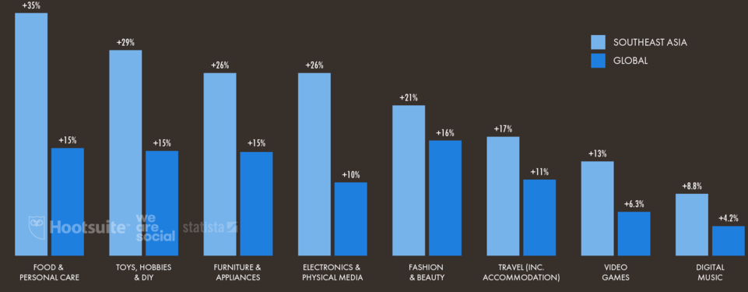

Promotional Activities:
 | INR (Cr)
Available Budget | 10
Activities
Try outs | 2.5
Billboards and handlers | 1.5
Health Awareness campaigns | 1.5
Total | 5.5
Ads
TV & Radio | 2
Social Media Marketing | 1
Newspaper and Pamphlets | 1.5
Total | 4.5
- Campaigns Supporting health-awareness:
  - Research has shown that 25% of the southeast population wants to avoid sweet and unhealthy options from their diet, and 52% have already shifted from an unhealthy breakfast to a healthy one.
  - Also, 62% of the consumers want to improve overall health, and the number keeps on increasing per year as the awareness increases.
So, showing our product as a healthy, affordable, and convenient alternative will boost our sales and help in increasing our market share.
- Try-out Stalls - Another cultural way of promotion in southeast Asian countries is giving potential customers a sense of taste of the final product in the shopping area to make them understand it. In the case of ready-to-mix products, the way is to have a demonstration near the stall multiple times a day to show the people how easy it is to make and how much less time it will take. It will be very effective as research has shown that 13% choose to skip breakfast and 14% skip lunch to save time. Also, 45% of consumers are dependent on convenience store foods to save as much time as possible, and the number is kept on increasing, but increasing health awareness is changing the perspective of the consumers.
- Billboards and Handlers - Another conventional way is to assign an individual in front of the shop, and their duty will be to flash a billboard showing our product and prices and a catchy phrase about how fast it can be made. But it is not a long-term solution. These methods are only practical during the first few weeks of the product launch to help spread product awareness.
- Ads & Social Media Marketing – We can also take the help of visual media and social media sites to spread awareness about our product. The most economical and effective one is social media marketing which will help us attract more customers, and since the social media trend is exponentially steep in southeast Asian countries, it will increase the chances of growing market share and revenue.

